Visits to Schools
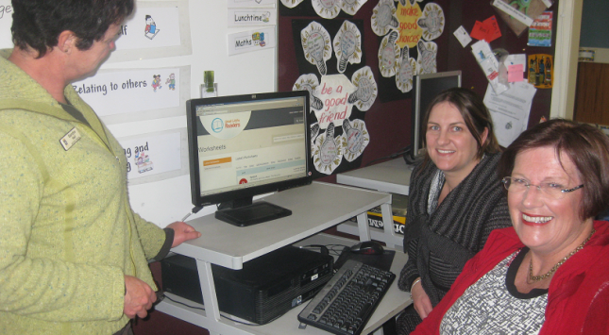

Angela (middle) and Lesley (right) have had a chance to visit some schools. We love getting to share our site with you and thoroughly enjoyed time spent with Sandra Neil (left) of Hillcrest Normal School, Hamilton.
Support For Christchurch
We are excited to share that we are providing free access to our website resources for Christchurch City schools. Many of you are well aware of the hardships that the schools down there are facing. The staffs, while coping with their own upheavals in relation to housing uncertainties, are also having to deal with uncertain roll sizes as children come and go from their classes due to parents having to move rental accommodation. On days when it all gets too much parents may keep children home or with them as getting the kids to school or picking them up when they have appointments to keep elsewhere becomes a logistic that is too complicated in fraught times. Schooling is disjointed, class sizes uncertain and stress levels for all concerned – high.
We were in a position to help and so have issued a challenge to all education supplies and service providers to do as we have done – dig deep and GIVE! The Education Gazzette have been fabulous in reporting what we are doing.
John Bangma, Principal of Mairehau Primary and head of the Christchurch Principals Association, has been wonderful to work with and we are grateful for his support in spreading the news to all Christchurch City schools
Our challenge culminates at the NZ-ED SHOW on the 13th, 14th and 15th September. The organisers are also giving our challenge their support and we hope to be able to drum up donations from the exhibitors at the show.

Maybe we will see you there???
Making Great Use of Our Resources
We are watching you! ☺
We continually keep an eye on who is accessing the website and what they are downloading. This gives us valuable information on our usage which we hope will enable us to provide the best possible service to you all.
One thing we have found is that a few schools have chosen to have one email address and password for all teachers. This may seem less complicated but the trend has been that these schools also seem to gradually use the resources less and less. We suspect that, because the teachers are not using their own emails and passwords over time they forget either or both and so, access becomes a hassle.
All schools have a nominated person who has the ability to approve or decline the subscriptions of other staff members. This practice seems to be the most effective in having staff use the website to its fullest potential.
Like us on Facebook http://www.facebook.com/pages/Great-Little-Readers
⇨Forward this newsletter to a teaching friend!
www.greatlittlereaders.co.nz
Quality resources for great teachers!

